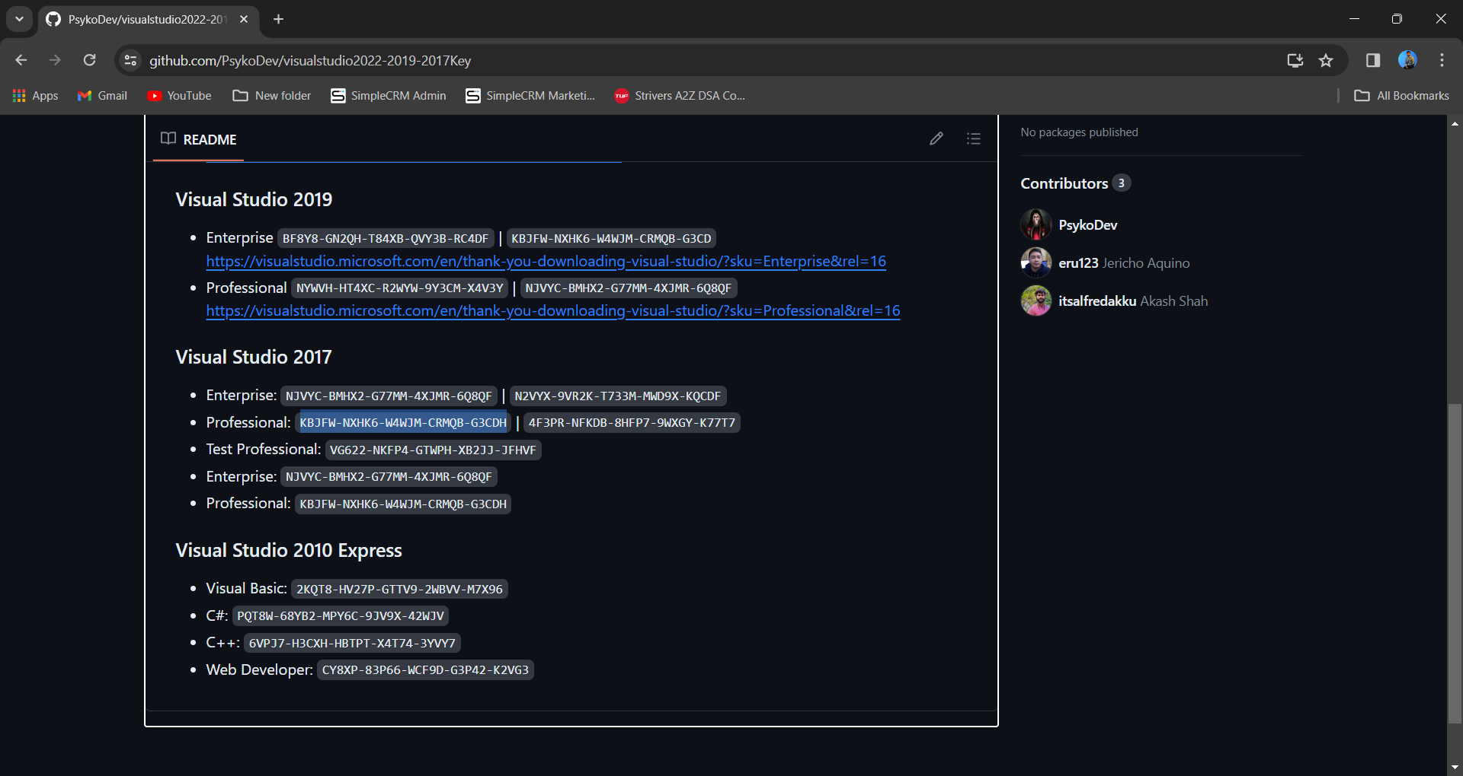

1. naming container
2. Find control inside naming container.
3. Dynamic binding eval function.
4. Display image in a grid view.

How to use single template field in a grid view control

Con not use block of code inside ispostback condition sol- Function

Task 1

Create a grid view in following format

Centre of the screen student

Roll – tb

Name – tb

City – drop down list

Button – update delete insert

All data display inside the control using eval.

Grid view paging concept.

Step

1. In grid view paging we have to use AllowPaging attribute.

(datareader read single record at a time)

Bulk reading Concept

1. Using dataset object
2. Using dataAdpater (BulkReader)
3. Dataset library – using system.data
4. Command cannot use (dataset, dataAdapter)

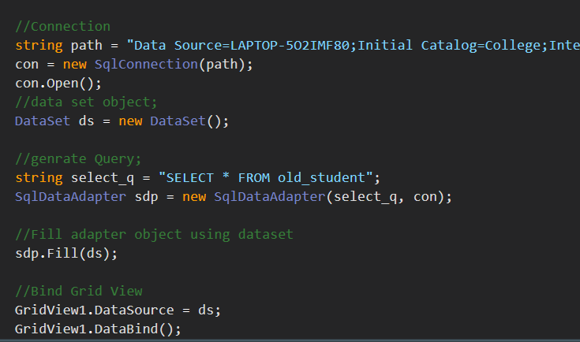

How to activate paging?

Activate the page in a grid view using OnPageIndexChanging event.

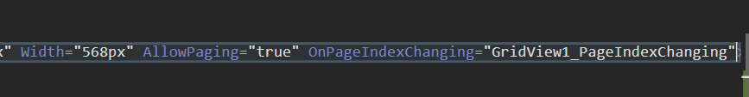

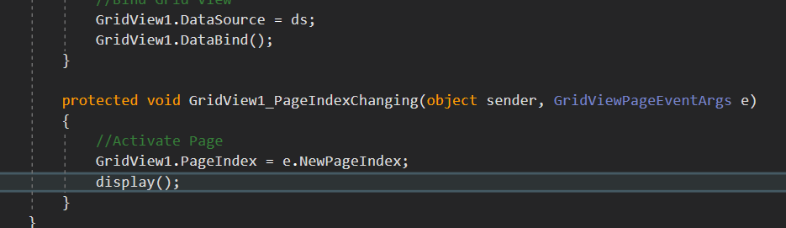

Database handling using class and object

1. Create a class

Repeater Control

Display data in row format.